> adopters <- function(time, stocks, auxs){
+ with(as.list(c(stocks, auxs)),{
+ N <- Potential_Adopters + Adopters
+
+ AR <- Effective_Contacts*
+ Adopters*
+ Potential_Adopters/N
+
+ dPA_dt <- -AR
+ dA_dt <- AR
+
+ return (list(c(dPA_dt,dA_dt),
+ Effective_Contacts=Effective_Contacts,
+ N=N))
+ })
+ }
> run_scenario <- function(run_id=1,
+ stocks=c(Potential_Adopters=9999,
+ Adopters=1),
+ simtime=seq(0,5,by=0.25),
+ Effective_Contacts=1){
+ auxs <- c(Effective_Contacts=Effective_Contacts)
+
+ res <- ode(y=stocks,
+ times=simtime,
+ func = adopters,
+ parms=auxs,
+ method="euler") %>%
+ data.frame() %>%
+ dplyr::as_tibble() %>%
+ dplyr::mutate(RunID=as.integer(run_id)) %>%
+ dplyr::select(RunID, everything())
+ }
> adopter_vals <- seq(0,1000,length.out=51)
> eff_con_vals <- seq(0,1,length.out=51)
> sim_inputs <- expand.grid(adopter_vals,eff_con_vals)
> summary(sim_inputs)
Var1 Var2
Min. : 0 Min. :0.00
1st Qu.: 240 1st Qu.:0.24
Median : 500 Median :0.50
Mean : 500 Mean :0.50
3rd Qu.: 760 3rd Qu.:0.76
Max. :1000 Max. :1.00
> run_id <- 1
>
> sim_res <- map2(sim_inputs[,1],
+ sim_inputs[,2],~{
+ res <- run_scenario(run_id = run_id,
+ stocks = c(Potential_Adopters=10000-.x,
+ Adopters=.x),
+ Effective_Contacts = .y)
+ run_id <<- run_id + 1
+ res
+ }) %>% dplyr::bind_rows()
Show Traceback
Rerun with Debug
Error: No CmdStan config files found. Set 'save_cmdstan_config=TRUE' when fitting the model.

> sim_res
# A tibble: 54,621 × 6
RunID time Potential_Adopters Adopters Effective_Contacts N
<int> <dbl> <dbl> <dbl> <dbl> <dbl>
1 1 0 10000 0 0 10000
2 1 0.25 10000 0 0 10000
3 1 0.5 10000 0 0 10000
4 1 0.75 10000 0 0 10000
5 1 1 10000 0 0 10000
6 1 1.25 10000 0 0 10000
7 1 1.5 10000 0 0 10000
8 1 1.75 10000 0 0 10000
9 1 2 10000 0 0 10000
10 1 2.25 10000 0 0 10000
# ℹ 54,611 more rows
# ℹ Use `print(n = ...)` to see more rows
> p1 <- ggplot(sim_res,aes(x=time,y=Adopters,color=RunID,group=RunID))+
+ geom_line()+
+ scale_color_gradientn(colors=rainbow(14))+
+ theme(legend.position = "none")+
+ labs(title="Adopters (Stock)")+
+ theme(title = element_text(size=9))
> p1

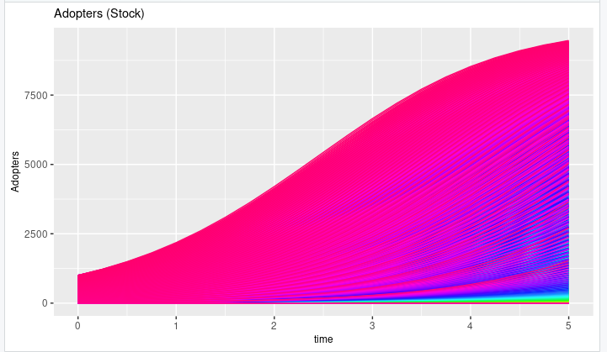

> max_a <- sim_res %>%
+ dplyr::group_by(RunID) %>%
+ dplyr::summarize(MA=max(Adopters),
+ A=first(Adopters),
+ EC=first(Effective_Contacts))
> p2 <- ggplot(max_a,aes(x=EC,y=A,z=MA))+geom_contour_filled()+
+ labs(title=paste0("Contour plot"))+
+ theme(title = element_text(size=9))
> p2

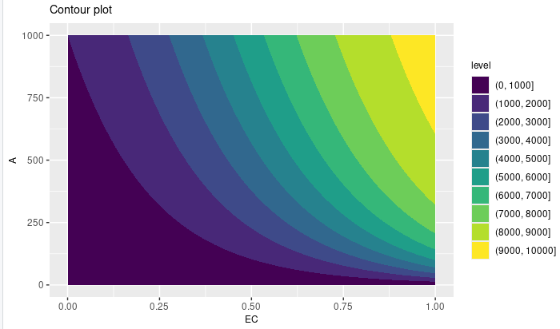

> p3 <- ggplot(max_a,aes(x=EC,y=A,color=MA,size=MA))+geom_point()+
+ scale_color_gradient(low="blue", high="red")+
+ labs(title=paste0("Parameter Analysis"))+
+ labs(subtitle=paste0("Max A = ",
+ round(max(max_a$MA),0),
+ " at point (0,0)"))+
+ theme(title = element_text(size=9))
> p3

